**Table of contents:**

1. Purpose and scope of IPACS v1 model

2. Model aims

3. Model overview and description

4. Installing and running the model

5. Model outputs

6. How to adapt the IPACS model for your locality

7. Assumptions and limitations

**1. Purpose and scope of IPACS v1 model**

The IPACS v1 model is a generic, open source, stochastic simulation model which enables scenario modelling of ‘Discharge to Assess’ (D2A) resource requirements. The name ‘IPACS’ stands for ‘Improving Patient flow between Acute, Community, and Social care’ and the IPACS project (2020-2023) was a research project set up to model these processes with a focus on D2A pathway resourcing. The project was funded by Health Data Research UK and involved Bristo, North Somerset, South Gloucestershire (BNSSG) Integrated Care Board (ICB), together with the local community health providers (Sirona), and three local authorities which provide social care: North Somerset, Bristol City, and South Gloucestershire. Researchers at the Universities of Bath, Exeter, and Bristol formed the core research team.

IPACS v1 models simple flows of ‘complex care‘ patients who have been identified as suitable for discharge from an acute hospital bed into a non-acute care setting for a further, time-limited, period of rehabilitation and assessment for their longer-term care requirements.

This is known as the ‘Discharge To Assess’ (D2A) process and it comprises three distinct care pathways where additional inputs of community health and social care are provided as seen in the flowchart:

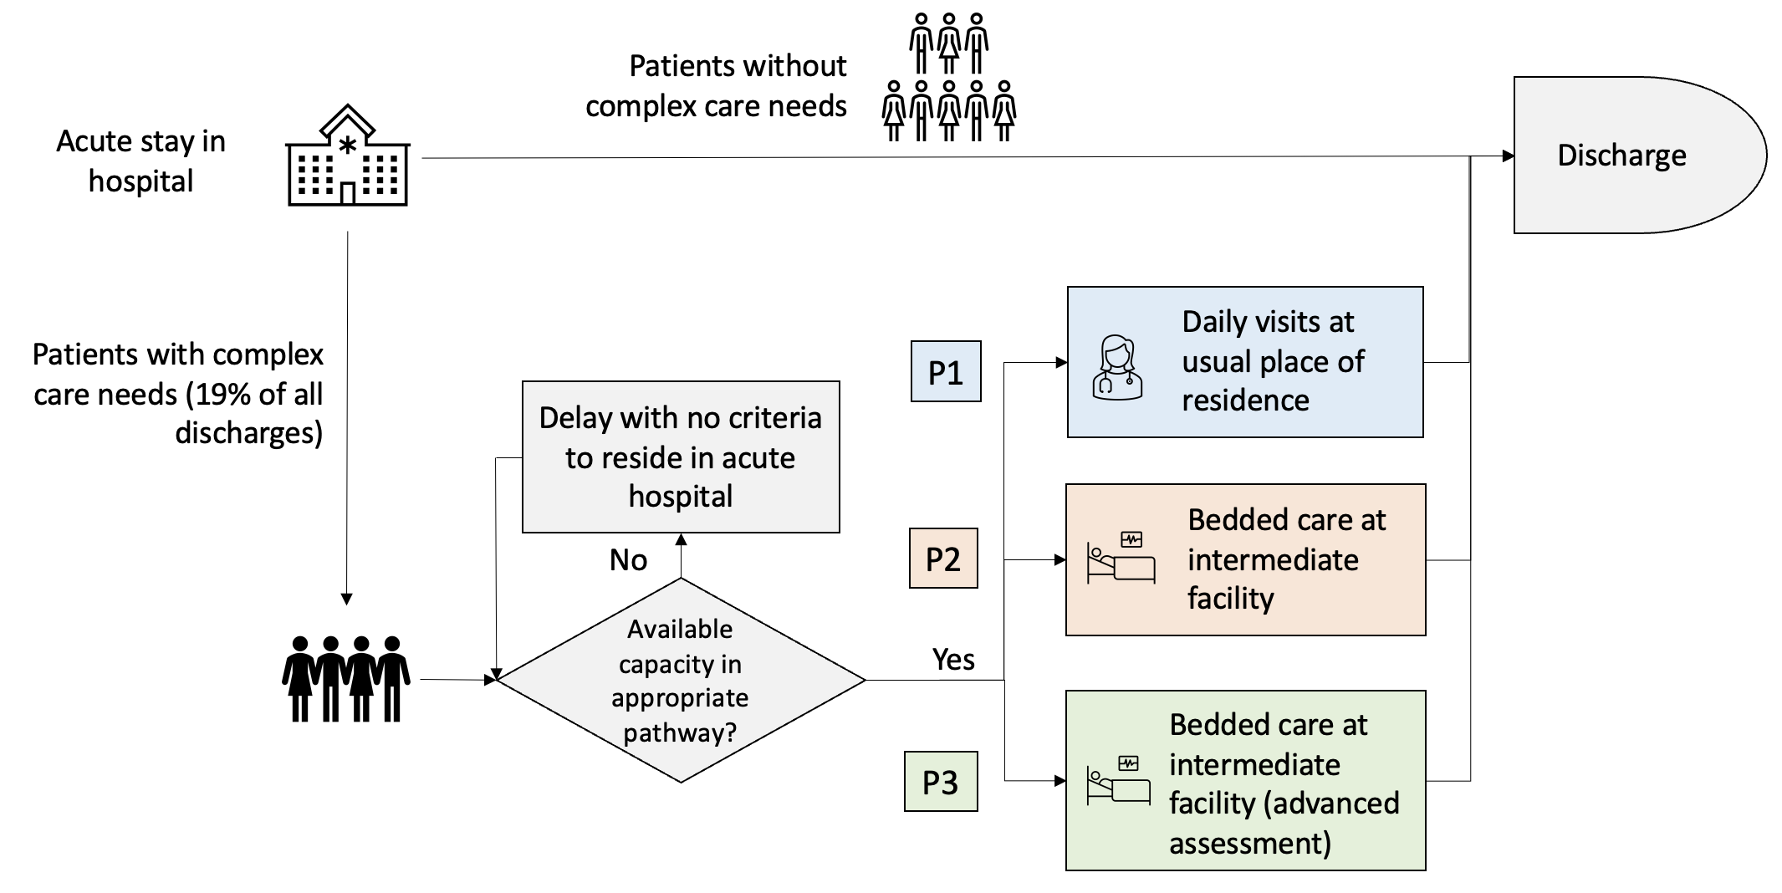

The complex care pathways are:

* P1 (visits-based care where the patient is in their own home and receives care inputs in that location. Funded by the community health provider)
* P2 (non-acute, bed-based care funded by the community health provider)
* P3 (non-acute, bed-based care funded by local authority social care provider).

A stochastic model (which incorporates variability in its inputs) is used as health care processes are variable by nature. Modelling solely using means or other summary inputs tends to underestimate capacity requirements and other outputs.

In BNSSG, P2 beds are located in either community hospitals or in care homes and all P3 beds are in care homes. This would be a typical pattern in other ICBs with exact proportions in different settings depending on local circumstances

**2. IPACS v1 Model aims**

1. Model patient discharges from acute care into intermediate D2A care pathways 1, 2 and 3 over time.
2. Enable experimentation to estimate the effects on service utilisation and discharge delays of different model parameters including:
   * referral rate into the D2A pathways
   * mean lengths of stay in D2A pathways (by locality)
   * variation in D2A pathway lengths of stay,
   * D2A capacity.

In addition – for the P1 pathway (where the patient Is in their own home) maximum and minimum number of visit requirements per day can also be varied.

**3. Model overview and description**

The IPACS model comprises a suite of two separate simulation models written in the ‘R’ software package (Version 4.2.2). The model subscripts are run from a single main script, such that very little essential interaction with the ‘R’ code is required. User inputs – data and scenarios to be tested - are all managed through a front-end Excel interface.

The model outputs are provided in Word (using R Markdown) and comprise descriptive text, a summary of the scenarios being tested, and a series of plots illustrating all scenarios for each complex care pathway and locality.

Two .csv files containing all of the underlying numerical values are outputted (one for P1/visits-based pathways; one for P2-3/bed-based pathways). These can be used for further analysis if required.

**4. Installing and running the model**

*a. Getting started*

* Ensure you have R (Version 4.2.2) and Rstudio installed

* Download the package from: https://github.com/nhs-bnssg-analytics/ipacs-nhsr-conf-2022

NOTE: Each folder contains an identical model package, with small changes to the input files, for training purposes. Choose one!

* This documentation is included in the package materials

* A sample excel input file is included in the model package – you can try running the model using the input file provided to get started.

The directory is structured as follows:

|HSMA_IPACS_Workshop_Exercise

| R main script

| R model subscripts

| Bed-based model

| Visits-based model

| IPACS_report.Rmd (output)

| Model inputs

| IPACS_inputs.xlsx

| Model outputs

|.csv files (outputs)

| Images

|.png files

| .Rmd

|LICENSE

|User Guide.docx

|README.md

|.gitignore

*b. IPACS Tutorial*

This provides a technical tour of the model and its main features (see Technical Appendix 2 to this document).

***Model Inputs/IPACS_inputs.xlsx***

The simulation model requires aggregate-level data to run, and this is read entirely off the .xlsx workbook, which is structured with five tabs. The next section describes these in more detail.

Each tab provides a field called ‘**node**’. The node is a linked combination of the pathway (P1, 2 or 3) and the locality (if multiple locality pathways are required). Ensure that there is a ‘node’ in each tab, and that it is formatted P1/2/3_locality. e.g.P1_LocA. Each node represents a service to be simulated, with a baseline case and any experimental scenarios.

Tabs ‘**arrivals’**, ‘**capacity**’ and ‘**los’** can be used to introduce scenario experimentation. Each of these include a column ‘scenario’ with will require a baseline (e.g. BArr represents baseline arrivals) for each locality and each date (where relevant). Where a scenario is tested, for each node (and each date where relevant) there will be a second scenario value (e.g. S1Arr represents scenario 1 arrivals). The values can be adjusted as required for each scenario (for example, arrivals+10%) for each node.

A maximum of 12 scenarios can be outputted, including the baseline, in order for the outputs to be digestible. This will include ALL COMBINATIONS of scenarios added. This means that for each of the variable parameters, two scenarios (including baseline) can be inputted. One variable may have a second scenario (for example you may wish to investigate arrivals +/- 10%). One suggestion is to use two scenario combinations (including the baseline) for each variable parameter (arrivals, capacity, los) plus adding an ‘infinite’ capacity scenario.

Mean **arrivals** are a daily input to the model, and have a ‘date’ field which will correspond to the model run time. Arrival rates are a ‘Poisson’ process, which is a discrete, normally distributed process. These are inputted daily for each node (and scenario, if relevant).

There are several ways this could be managed. For example:

* You could simply use mean current referral activity and project this forward for the desired time period;

* You could use mean current referral activity per day of week and project his forward over time.

* Apply a ‘growth factor’, for example a winter uplift if that is part of your model run time horizon and you reasonably expect demand to change;

* Supply other estimates as available, such as forecasted demand, which may be based on forecasted acute arrivals adjusted (for example) for acute los, proportion of complex discharges, and proportion entering each pathway.

* For each locality, the overall numbers can be varied across pathways, for example to experiment with a scenario of reducing referrals into bedded pathways, and increasing referrals into P1-type pathways.

* In all cases the data input process is the same with the number of rows of data depending on the time horizon to be modelled, as well as the node (number of pathways and number of localities) and scenarios (baseline +/- other scenario)

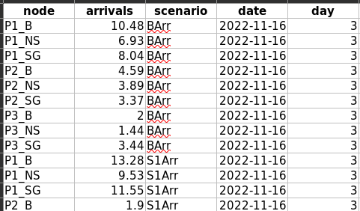

Capacity is the current capacity in terms of beds (for P2/3 pathways) and number of patients accommodated (for P1 pathways). It is entered per node (and scenario, if relevant). For an ‘infinite capacity’ scenario, enter a very large number (eg 2000) to look at how much capacity is required to have no acute patient discharges delayed.

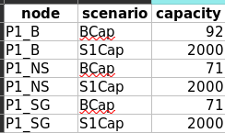

Length of stay (los) is inputted as the mean, and median for each node. The distributions and distribution parameters are calculated from these inputs and do not need to be adjusted. Additionally, for P1 pathways, two additional, optional parameters are provided. These are ‘IVR’ and ‘FVR’, which correspond to ‘Initial visit rate’ and ‘final visit rate’. These used for calculating P1 visits-based capacity based on time-varying capacity requirements, assuming that patient visit requirements decrease across their service duration. The default settings are a mean IVR of 4, and a mean FVR of 1. Note that the upper limits are truncated in the model code.

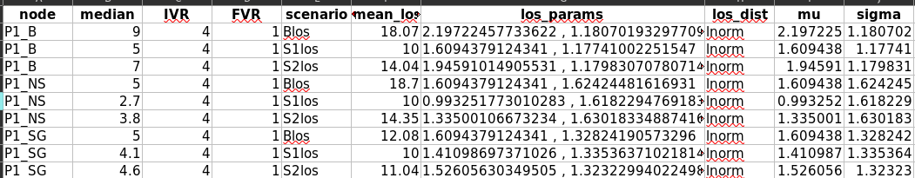

Tab ‘initial conditions’ initialises the model with the starting system state for ‘no criteria to reside (nctr)’ and ‘pathway occupancy’ (occ) for each node.

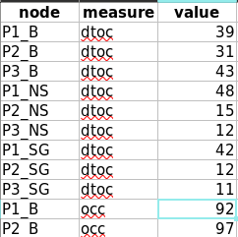

Tab ‘costs’ provides daily indicative costs for one day of acute care, and one day of community care per pathway node. This enables an estimate of the total system cost of different scenario combinations, as a combination of the cost of acute delays and the cost of community service provision.

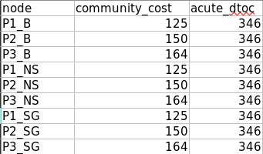

The costs provided in the input file are derived as follows:

|  |  |  |  |
| --- | --- | --- | --- |
|  | Average cost of weekly service | Relative Cost ratios | Source of costs |
| P1 | £875 | 5 | 2017/18 NHS reference costs |
| P2 | £1,050 | 6 | National Audit of Intermediate Care 2017/18 |
| P3 | £1,150 | 7 | System costs from Bristol care system |
| Acute | £2422 | 14 | 2017/18 NHS reference costs |

***Understanding the code***

The model can be run with very little interaction with the model code. The basic requirements are the following:

* Save the package into a local directory

* Open Rstudio in the directory, or alternatively, open Rstudio, and navigate to the directory in the ‘Files’ tab

* Open the input file .xlsx and update parameters if you wish. Save and close the file.

* Open IPACS_model_mainscript

* Set your working directory (there are multiple ways to do this)

* Run IPACS_model_mainscript

* An Rmd .docx will be generated in the package folder, and inside the model_output folder you will find the accompanying .csv output files.

***Modifying the model/code:***

Inside the R_model_subscripts folder you will find the two R models.

Comments are provided to allow you to understand what the code is doing. You are welcome to modify or re-use the models/code as required. The main script reads the excel parameters, runs the two submodels, and runs the .Rmd script. .csv outputs are generated by the submodels. Plots are generated within the .Rmd file based on the .csv files and can be adapted here.

**5. Description of model outputs**

The Output file contains information about the parameter inputted into the model, and a set of plotted outputs. There is one plot per node (pathway, locality) with all combinations of scenarios. For example: 2 arrivals scenarios, 2 los scenarios, 3 capacity scenarios:- 2*2*3 = 12

Each plot contains four facets:

* The mean number of patients estimated to be in service over the model run time. This is constrained by the capacity set for each scenario.
* The mean number of patients estimated to be delayed in the acute sector. This is an outcome of capacity constraints in the pathway.
* The estimated mean number of days delayed per patient in the acute sector. This provides information about lost bed days, for example, the mean number of patients delayed multiplied by the mean number of days delayed.
* The estimated overall system costs for each scenario – this is calculated as the mean cost of delayed discharges plus the mean cost of community service provision for each scenario.

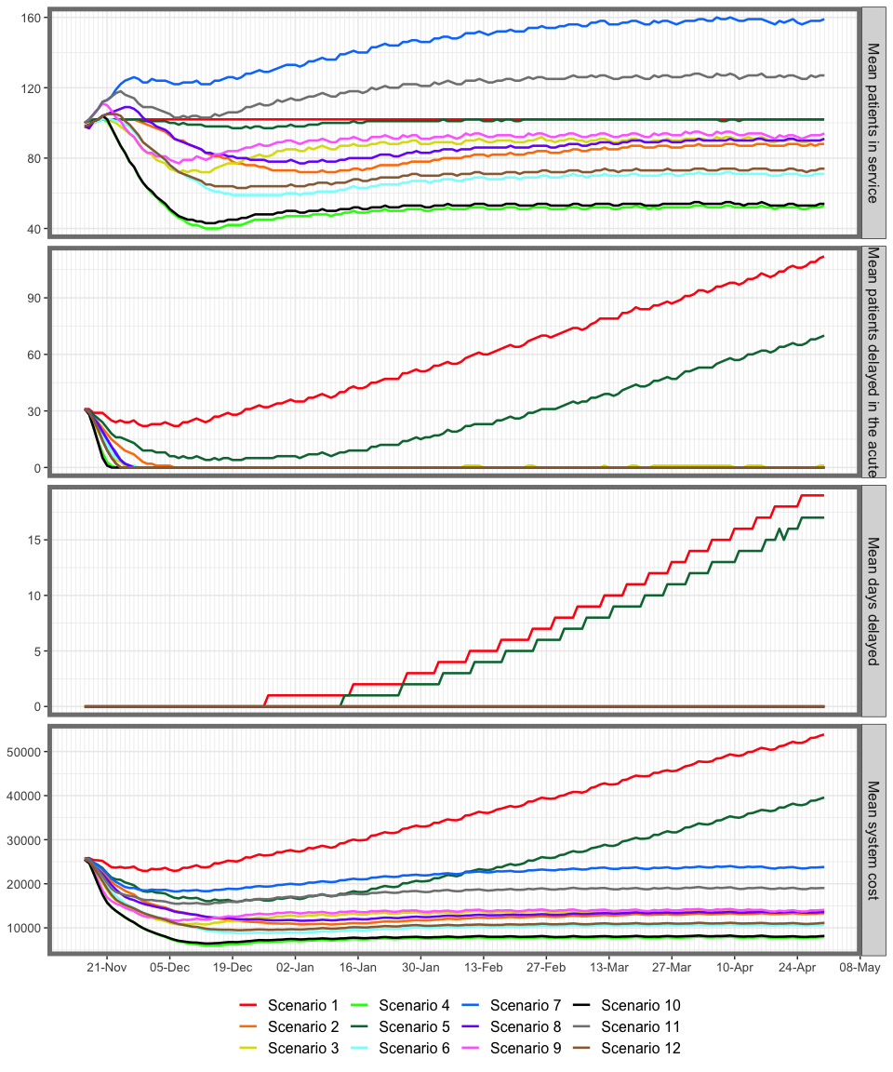

**6. The IPACS model: tailoring it to your locality**

As described above, the IPACS model requires some current local system state data in order to initialise the model and enable relevant outputs to be produced. A detailed list and definitions of the data follows further below but, in summary, the requirements are:

* numbers of patients already in the P1-P3 pathways

[in .xlsx: initial conditions tab, measure = occ]

* current available capacity (ie. number of beds (P2, P3); home care caseload capacity (P1))

[in .xlsx: capacity tab]

* average length of stay for a patient in each complex care pathway and each locality
* [in .xlsx: los tab. Enter median and mean los]
* the number of patients currently delayed in acute beds who have been assigned to a D2A pathway but cannot be discharged into it because there is no capacity

[in .xlsx: initial conditions tab, measure = nctr]

* the number of patients of referrals for each pathway (I.e. activity demand)

[in .xlsx: arrivals tab, required daily inputs]

Note that if exact values for any of these parameters are not readily available then you can always enter an ‘expert guess’, or a national average figure to use as a starting point and simply revise this as more specific or accurate local data become available. Any changes will be immediately accounted for the next time the model is run.  
  
  
  
 **END**

**Technical Appendix 1: Steps for Installing and running IPACS v1 tutorial**

IMPORTANT: The following instructions assume that you already have the simulation modelling package ‘R’ and ‘R Studio’ installed and accessible on your computer or local network. If not, please arrange to do this before continuing.

**Step 1 Installing the files from Github**

Create a folder (eg. ‘IPACS Model’) and copy all of the IPACS model files from one of the Github folders into it. All of the following files need to be in the same folder:

* model_inputs/*IPACS_exercise.*xlsx
* IPACS_model_masterscript.R
* Visit_based_slavescript.R
* Bed_based_slavescript.R
* .Rmd script
* An ‘output’ folder which holds .csv outputs
* An ‘images’ folder holding the images used within the Rmarkdown report.
* The .csv ‘IPACS input data.csv’ also provides some information to the Rmarkdown document

**Step 2 Input parameters**

* Open model_inputs/*IPACS _exercise.xlsx.* Change any parameters as required. We suggest using current local values as a starting point.
* Please ensure you keep to the same format.
* Add scenarios as required – change the scenario name and the values only.
* Save and close the file.

***Step 3 Running the IPACS model***

Launch ‘Rstudio’ and open the file: *IPACS_model_masterscript.R*

Set the directory for your input files:

* In the console window (bottom left window) set the ‘working directory’. This enables the model to find the folder where your data files are held (ie. the folder which you set up in Step 1).
* To set the working directory, write getwd() in the console window and copy the output which is produced by this command to “setwd(“C:/Users…”) in the script window (top left window).
* Run the script by selecting Code->Run Region-> Run All from the menu. You can also use the shortcut *(‘Ctrl + Alt + R’ for Windows or Linux users, or ‘Cmd + Alt + R’ for Mac Users).*

***Step 4: View results:***

* Check the new outputted Word document
* Check the .csv files inside the outputs folder

***Step 5: Running different scenarios:***

* You can change scenarios in model_inputs/.xlsx
* A maximum of 2 * 2 * 3 scenarios can be run, including baselines, by varying arrivals, capacity, and los. This will output 12 scenarios per plot with mean outputs.
* If you wish to investigate further scenarios, we recommend creating a separate output report by changing the name of the .Rmd file (last line in the IPACS_model_masterscript.R) and running a further set of scenarios for comparison.

**END**

**Technical Appendix Appendix 2: Tutorial**

**Add workshop slides here?**

Yes – a summary – I can do that next week. Will need to update the package structure slightly first, and annotate the code .